**Advanced Software Engineering**

**Challenge #1**

**Report**

**By**

**Jeevana Tunuguntla(class Id: 41)**

**Saitejasree Ramala (Class Id: 51)**

**Students’ name/ID**

Jeevana Tunuguntla(16170437)

Saitejasree Ramala(16172566)

1. **Design**

In this application, the user enters the particular grocery website. If the user is at a different location and wants to get to the store, he/she can use the directions service from the website which will help the user to get to the store by using Google Maps. Then if the customer wants to do online shopping from the mobile, they can go the catalogue service in the website where the available products are listed along with their quantity and price. Here, the user can select the items and add them to the cart. Once the items are finalized, they can pay the amount and complete the order of the products. If the user wants to contact for any of their doubts, they can do so by call or email services provided in the contact us field. If the user wants to give their feedback then they can do by the email service in the feedback field.

**a. Architecture Diagram**

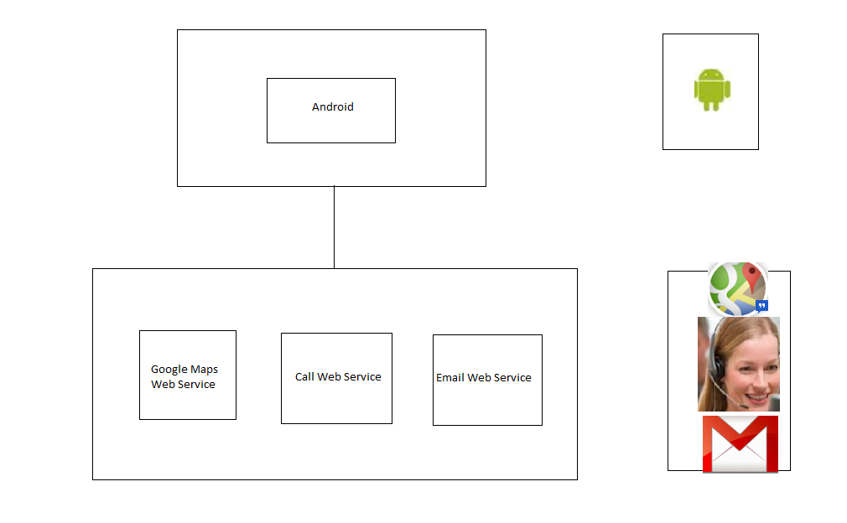

**b. Class Diagram**

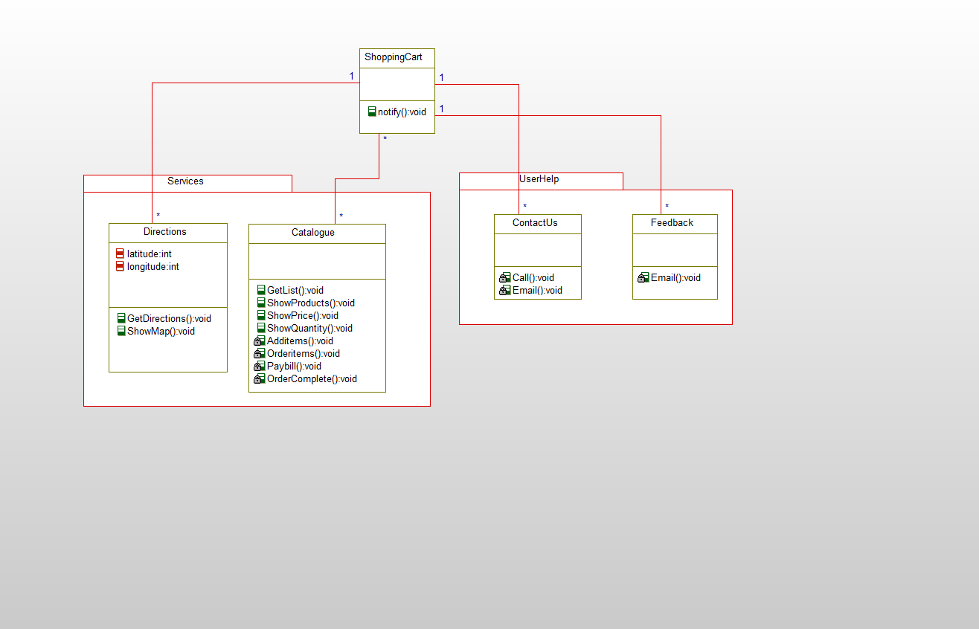

1. **Features Implemented**
2. **Web Services**

* Google Maps Web Service
* Call Web Service
* Email Web Service

1. **Your own services**

Catalogue

Make Payment

Feedback

1. **Existing services/APIs**

Google Maps API

1. **Database**

The Database field includes the data of the store, like where is the store located and how to reach the store from different locations which includes the Google Maps service. Then the available items of the store along with their price is stored. Also the call and Email services data is included.

1. **Your own data model/data sources**

Our own data model includes calling the Google Maps web service for providing location help service to the users and helping the users to search according to their requirements like BBQ accessories, Bathroom essentials, Kitchen essentials etc. Providing the users to help us by giving their feedback of what is good and what needs to be improved and also contacting us for any of the service necessary for them in their order.

1. **Existing data model/data sources**

Google Maps API

HTML Web Page

1. **Mobile User Interface**
2. **Your own design**

In this application, the user enters the particular grocery website. If the user is at a different location and wants to get to the store, he/she can use the directions service from the website which will help the user to get to the store by using Google Maps. Then if the customer wants to do online shopping from the mobile, they can go the catalogue service in the website where the available products are listed along with their quantity and price. Here, the user can select the items and add them to the cart. Once the items are finalized, they can pay the amount and complete the order of the products and the payment successful message will be displayed on HTML web page. If the user wants to contact the site, they can do so by call or email services provided in the contact us field. If the user wants to give their feedback then they can do by the email service in the feedback field.

1. **Existing design**

We made use of Google Maps, Call and Email Web Services and also used HTML web page for the payment successful web page.

1. **Include Screenshots of the Features**

When the user opens the website, the screen will be displayed as below



The services screen in the website is shown below



When the user selects a particular item, then the items selected are displayed as

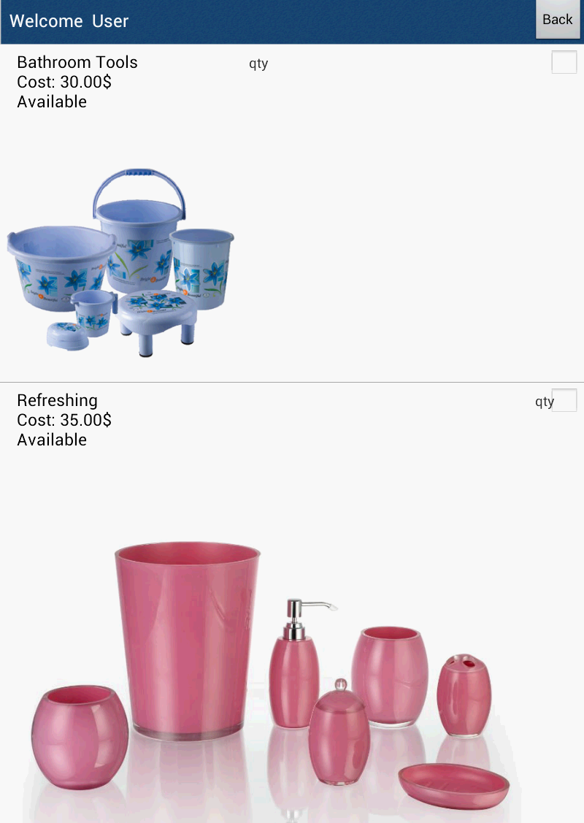

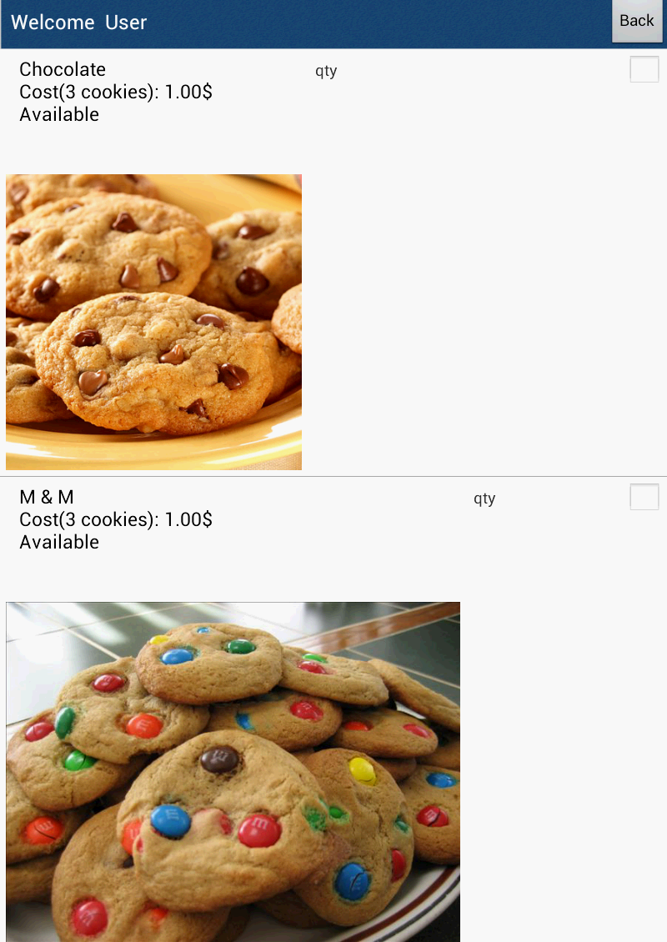When the user wants to contact by the contact us field then the screen is shown as 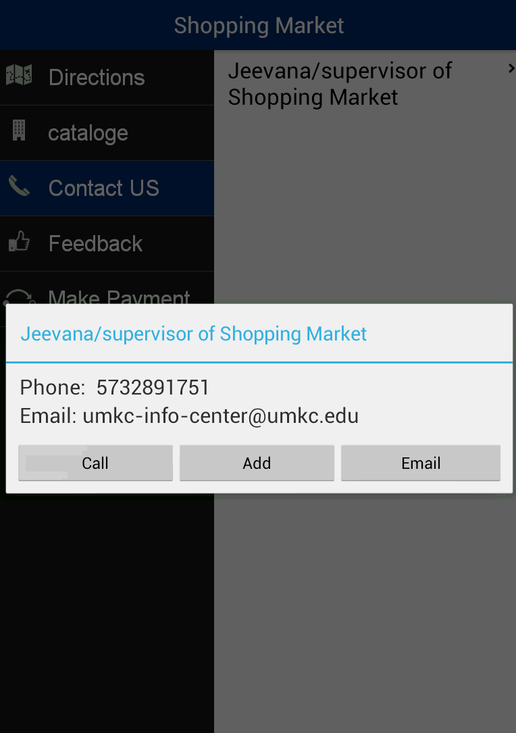 The pay

The make payment screen is given as below

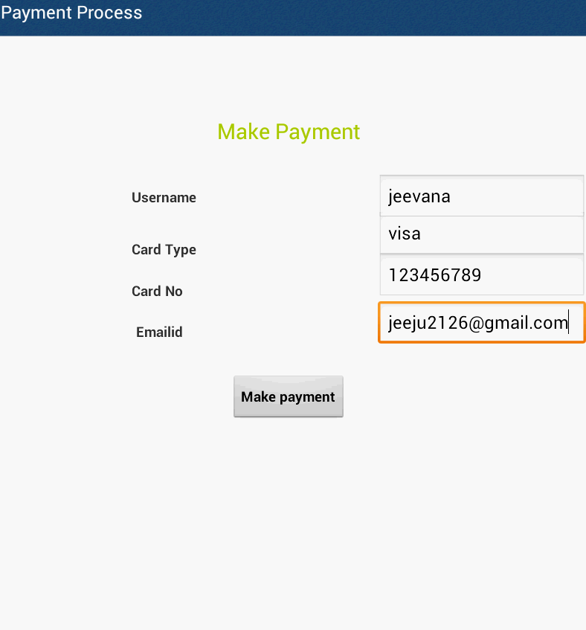

The feedback screen is as follows

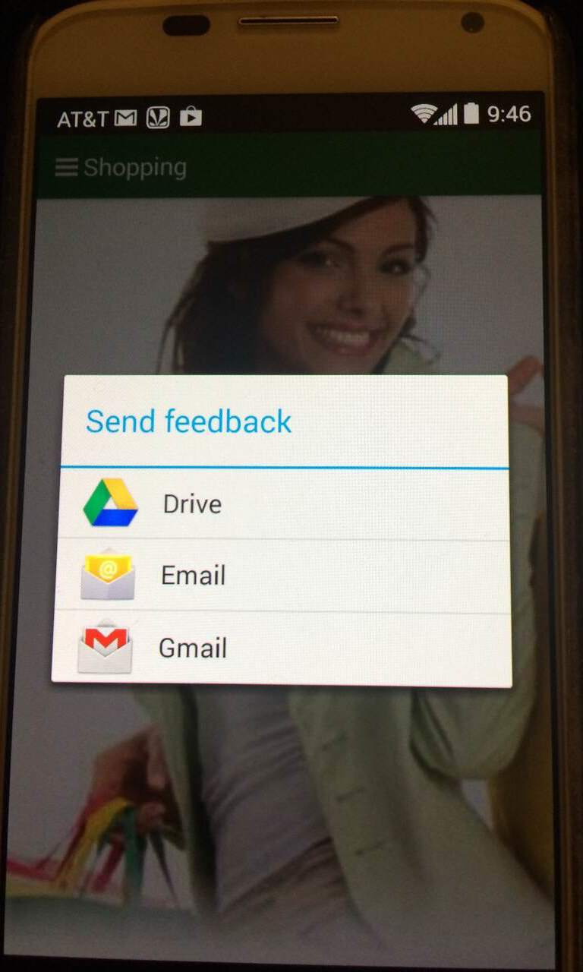

The payment successful screen using HTML is shown as

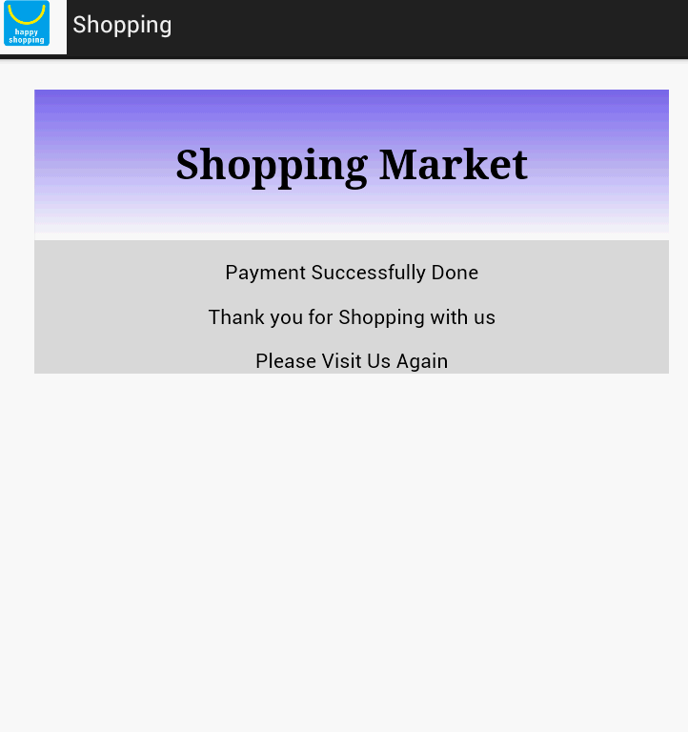

**4) Include all the Web Service and Web Site URLs**

Google Maps Web Service

Call Web Service

Email Web Service

**5)Include your Challenge#1 Github URL**

**https://github.com/jeeju/AseChallenge1**

**6) Limitations**

1. We didn’t used paypal services for making payment.
2. The user survey is not shown with the advice shown from other users
3. We didn’t make use of multi lingual services for our application.

**7) References**

[**http://developer.android.com/index.html**](http://developer.android.com/index.html)

[**http://developer.android.com/guide/webapps/index.html**](http://developer.android.com/guide/webapps/index.html)

[**https://www.coursera.org/course/android**](https://www.coursera.org/course/android)

[**http://www.walmart.com/cp/Walmart-Mobile-App/1087865**](http://www.walmart.com/cp/Walmart-Mobile-App/1087865)

[**http://www.cozi.com/androidapp.htm**](http://www.cozi.com/androidapp.htm)